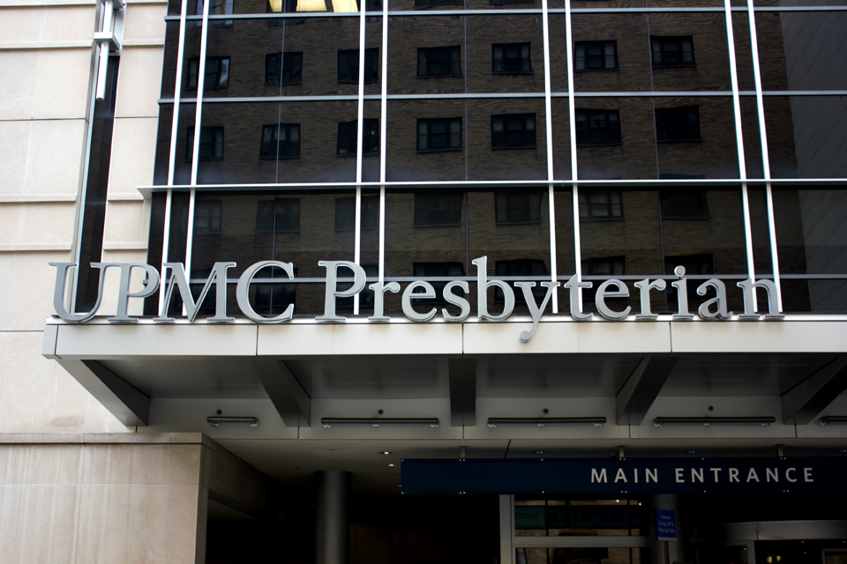 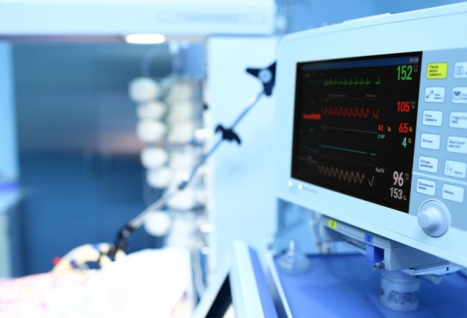

Dr. Benedict provides insight into the training requirements and personal skills that will promote success in this field.

Dr. Benedict describes the professional responsibilities, patient population, and practice site typical for a Critical Care Clinical Pharmacist.

#### **What does it take?**

#### **What does he do?**

Dr. Benedict is a Critical Care Clinical Pharmacist at the University of Pittsburgh Medical Center (UPMC). He is also an Associate Professor at the University of Pittsburgh School of Pharmacy in the Department of Pharmacy and Therapeutics. He received his Doctor of Pharmacy degree from the Mylan School of Pharmacy at Duquesne University in 2002.

Following graduation, Dr. Benedict completed a PGY1 Pharmacy Practice residency at Kaleida Health in Buffalo, NY. Next, he completed a PGY2 Critical Care Specialty residency through the University of Pittsburgh.

Alongside his clinical and academic responsibilities, Dr. Benedict precepts both 1st and 2nd year residents enrolled in the University of Pittsburgh School of Pharmacy Residency Program.

#### Page 4

#### Page 2

Clinician of the Month – Student Society of Health-System Pharmacy

Dr. Neal Benedict

Critical Care Inpatient Pharmacist

February 2016

Clinician of the Month!

## 6:00-7:00am

## *Nonclinical work related to teaching, research, or service responsibilities*

## 7:00-8:00am

## *Individual patient assessment and recommendation development*

## 8:00-11:00am

## *Rounds with the Critical Care Medical team*

## 11:00am-4:00pm

## *Teaching, research, service requirements and team follow-up*

## ~4:00pm

## *Home for the Day!*

A Typical Day in Critical Care

Primary responsibilities, practice sites, and disease states commonly treated in critical care

## What does a Critical Care Clinical Pharmacist do?

As a Critical Care Clinical Pharmacist, Dr. Benedict’s career includes daily patient care. Consequently, some of his primary responsibilities include daily patient assessment, recommendation development, and patient care rounds as part of an interprofessional team. He also spends time educating and discussing treatment plans with both patients and their families. Additionally, Dr. Benedict is responsible for providing drug information and patient recommendation communication and follow-up as the pharmacotherapy expert of the team.

In addition to his responsibility to his patients, Dr. Benedict is responsible for extensive collaboration within a healthcare team. Dr. Benedict explained that each day of patient care rounds provides opportunities for the critical care pharmacist to train other healthcare providers regarding available evidence and/or clinical experience with specific pharmacotherapy decisions.  For example, the pharmacist might explain why one antibiotic might be more effective for a patient than another, or why a specific sedative might be more safe and effective in a given patient based on current literature and consensus statements. At its core, the role of a Critical Care Pharmacist is to provide patient-centered care, so as the pharmacotherapy expert, he or she must be willing to educate physicians, nurses, other pharmacists, patients, and other members of the healthcare team regarding pharmacotherapy decision making. Additionally, critical care pharmacists participate in more formalized education to allied health professionals in the form of in-services and continuing education programs.

On top of his position as a Critical Care Clinical Pharmacist, Dr. Benedict is an Associate Professor within the Department of Pharmacy & Therapeutics at Pitt. Consequently, there are research, teaching, and service requirements that align with his critical care acumen and accompany his patient care responsibilities. Dr. Benedict indicated that these responsibilities are specific to his position—not all critical care positions are affiliated with a faculty appointment. Instead, many critical care pharmacists work for hospitals and have hospital-based roles that accompany their clinical responsibilities.

Dr. Benedict practices at UPMC Presbyterian hospital in a Level 1 surgical/trauma ICU. The ICU holds 22 beds, and the patient population is generally severely ill. Patients are 18 years or older and admitted following a surgical or traumatic event.

Dr. Benedict listed several disease states that he commonly encounters, including pneumonia (community/hospital/ventilator-associated), sepsis, thromboembolism, pain, agitation, delirium, hyperglycemia, alcohol withdrawal, renal disease, fluid management and electrolyte abnormalities.

With such sick patients requiring care, it’s not surprising that Dr. Benedict does not work alone. His healthcare team is extensive. A typical Critical Care medicine team within his ICU consists of one Critical Care attending physician, one Critical Care fellow, two – three medical residents, and one or more medical student~~s~~. The teams also include various other healthcare professionals, such as respiratory therapists, dieticians, and social workers, to name a few.

**Yes!** Availability in Critical Care Pharmacy is growing. Many hospitals are attempting to integrate pharmacist clinicians into all ICUs within their facility.

**Know your value:**  
Critical Care pharmacists enhance safe medication practices within a high-risk patient population—the critically ill.

Are jobs available?

#### **Dr. Benedict’s *favorite* aspect of his profession:**

*Critical Care Pharmacy incorporates daily interactions with other healthcare professionals and patients.*

#### **Dr. Benedict’s *least favorite* aspect of his profession:**

*Rounds are unpredictable. They can last as short as 90 minutes or as long as 4 hours. It becomes difficult to schedule and prioritize your workday/work week with that amount of uncertainty.*

## Where does a Critical Care Clinical Pharmacist practice?

**What type of training is required to practice as a Critical Care Clinical Pharmacist?**

In order to practice as a clinical pharmacist in the inpatient, critical care setting, specific residency training is expected. First, graduates complete a Pharmacy Practice PGY1 residency. The PGY1 residency that one selects provides general training within a hospital setting; this valuable training period affords new pharmacists the opportunity to hone the skills they learned in school as part of an interdisciplinary team. The program helps residents sharpen their abilities to think critically and develop skills in a variety of specialties. Graduates then typically complete a PGY2 Critical Care Specialty residency program. This will provide advanced training with a focus on Critical Care Pharmacy.

**In addition to the appropriate training, Dr. Benedict described several skills that make a good Critical Care Clinical Pharmacist.**

First, he identified **judgment** as a critical skill. Critical Care Pharmacists must be able to make calculated pharmacological decisions that are evidence-based and reached through some degree of consensus among the healthcare team and with the patient. Dr. Benedict pointed out that recommendations must be made effectively and efficiently in this field.

Equally important is **drive**. Dr. Benedict mentioned that preparation for patient care rounds requires detailed patient assessments and thoughtful recommendation development. The Critical Care pharmacist must truly desire to serve as an advocate for the patient as he or she develops these intricate plans. The pharmacist must then work cohesively with the healthcare team to promote positive patient outcomes.

Finally, Dr. Benedict emphasized that **communication** is essential in his field. Developing a respected, professional, and positive rapport with the interprofessional team is vital to the critical care pharmacist. This involves frequent, but thoughtful communication as the pharmacotherapy expert on the team. Dr. Benedict specifically noted that pharmacists’ effectiveness and efficiency can be marginalized with poor communication.

Training requirements and essential skills for success in Critical Care

What does it take?

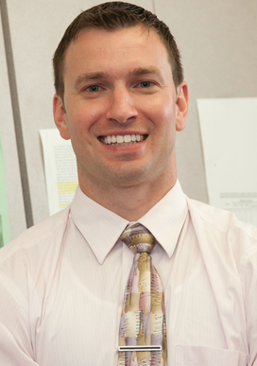

Interestingly, despite his busy schedule, Dr. Benedict has three young kids at home. As a result, he works hard to balance family life with work. How does he do it? Time management is key to being successful in the field of Critical Care Pharmacy. Dr. Benedict utilizes early morning hours from 6:00am until 7:00am to prioritize his day/week and address outstanding issues with non-clinical work. As a result, he is able to minimize the amount of work that he needs to take home in order to maximize his time with his family. So why did he choose such a demanding field? Dr. Benedict indicated that he chose Critical Care because he enjoys the opportunity to collaborate with other healthcare professionals through the provision of impactful recommendations. Ultimately, his work as a Critical Care Clinical Pharmacist is improving patients’ lives!

# Why did Dr. Benedict choose Critical Care?

### How does Dr. Benedict manage his time, and what makes it all worth it?

Clinician of the Month – Student Society of Health-System Pharmacy

February 2016